About us:

Since 2016 Top Notch Plumbing, LLC has provided plumbing services to Colorado. We take “Protecting the Health of the Nation” seriously. Our priorities are safety, quality, and integrity.

Competencies:

- Provide plumbing repair, service, and maintenance to residential, commercial, industrial, and medical settings.
- Provide plumbing installation in commercial, residential, industrial, and medical settings.

Differentiations:

- 8(a) Certified
- Medical Gas Installation
- Certified Brazing
- Backflow Testing
- Core Drilling

Point of Contact:
Adrian Vigil, CEO and Owner
Office: 970-404-7586
Cell: 970-702-1228
Email: adrian@topnotchplumbingllc.com

Company data:
Top Notch Plumbing, LLC.
1913 9th Street Greeley, CO. 80631

CAGE: 867N5

DUNS: 09-550-5872

NAICS: 238220

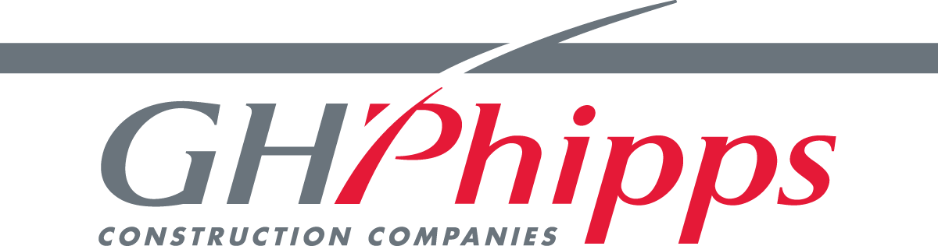
Past Performance:

